Assignment #4: Rotational Motion
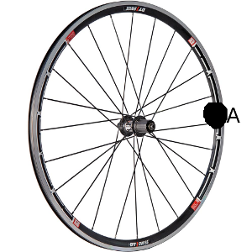
- You are looking at point A on the wheel. The wheel is rolling counterclockwise. It spins 8π radians in 2 seconds. Its radius is .3 m.
  - What is the arc-length (distance) that point a has traveled?

  - What is the rotational velocity of the wheel (speed and direction)?

  - What is the linear velocity of the wheel?

  - What is the time it would take the wheel to make 10 complete rotations?

  - How far does point A travel during that time? (Arc-length)

- The mass of the earth is 5.974 kilograms. Its radius is 6.387* 10⁶ m. The moment of inertia for a solid sphere is given by . The earth rotates once every 24 hours.
  - What is the rotational velocity of the earth (in radians per second)?

  - What is the Moment of Inertia of the earth?

  - What is the rotational kinetic energy of the earth?

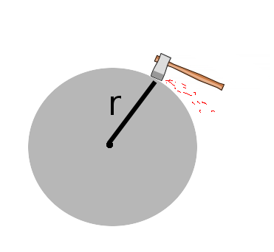
- Isaac is sharpening his axe on a grinding stone, using a force of 100N. The radius of the stone is 0.25 meters. The moment of intertia of the stone is 75 kgm². Initially, the wheel makes 3 rotations per second. After 20 seconds, the wheel comes to a complete stop.
  - What was the angular acceleration of the wheel?

  - What is the torque exerted by friction?

  - What is the coefficient of friction (ignore gravity).

  - How many rotations does the wheel make before coming to a complete stop?

  - What is the speed of the wheel (in radians per second) after 7.5 seconds?

  - What is the tangential velocity of the wheel at 17.3 seconds?

